Data Structures for a Production Line Quality Inspection System: Optimization, Scaling, and Final Evaluation

Sandip Sitaula
University of Cumberland
MSCS-532-B01: Algorithms and Data Structures
August 4, 2026

Data Structures for a Production Line Quality Inspection System: Optimization, Scaling, and Final Evaluation
Optimization Techniques
The Phase 2 version already used good structures for each job: a dict for fast lookup, a deque for the station queue, a heap for triage, and a trie for SKU checks. None of these were slow in theory, so this phase looked for smaller problems instead, things like memory use and repeated work, rather than swapping out a whole structure for a better one. Four changes were made and each one was tested before and after, instead of just assumed to help.
Memory (slots)
InspectionRecord now uses slots (@dataclass(slots=True)). Normally a Python object keeps a small dictionary just to hold its own fields, and that dictionary takes up extra memory for every single record. Slots remove that dictionary. Since the registry can hold tens of thousands of records at once during a big batch, this adds up. Testing at four sizes, from 100 up to 100,000 records, showed the slotted version using about 17 to 25 percent less memory, with the biggest savings at the smallest size and settling around 17 percent from 1,000 records on.
Loading in bulk (heapify)
TriageQueue can now load a whole batch at once with load_many, using Python's heapify function. Adding units one at a time costs O(log n) each, so n units costs O(n log n) total. Heapify builds the same heap in O(n) instead. This matters if a big group of units is already waiting at the start of a shift, instead of arriving one by one. Testing showed load_many was faster in every case, but only by about 1.1 to 1.4 times, not a huge jump. Repeating the same test a few times also showed the two methods swapping places sometimes, so this result should be treated as a small, somewhat noisy improvement rather than a guaranteed one.
Caching lookups
SKUTrie.contains now remembers recent exact matches instead of checking the tree again. The cache clears itself automatically any time insert adds a new SKU, so it can never give an old, wrong answer. This helps when the same popular SKU gets scanned over and over during a shift. Testing 10,000 lookups on the most common 5 percent of a catalog showed the cached version was 3 to 7 times faster on smaller catalogs, but only about 1.4 times faster once the catalog reached 100,000 SKUs. That drop was a bit of a surprise, since a trie lookup should not care how big the catalog is. The most likely reason is that a much bigger trie no longer fits well in the CPU cache, which slows down every lookup a little, cached or not.
Setting a memory limit
StationQueue can now take an optional maxlen limit. This is not about speed, it is about memory. A real station only has so much physical space, so the queue should not be allowed to grow forever if units pile up faster than they can be processed. Once the limit is reached, the oldest waiting unit is dropped automatically, and a new dropped_count field keeps track of how many units were lost so the problem is visible instead of silent.
Scaling Strategy
Scaling was tested using made up data at four sizes, 100, 1,000, 10,000, and 100,000, generated with Python's random module, the same approach used since Phase 1. A bigger single test of 500,000 units was also run to see how the system holds up further out. Building 500,000 registry records and adding them to the queue took 0.925 seconds. Draining the queue while updating each record took 0.847 seconds. Draining all 500,000 units from the triage queue took 0.799 seconds. All three stayed close to linear as n grew, matching the O(1) and O(log n) behavior claimed back in Phase 1.
The clearest result in this phase actually came from checking a Phase 1 decision, not from a new optimization. StationQueue uses collections.deque instead of a plain list. A list based queue using list.pop(0) is O(n) per removal, since every remaining item has to shift over by one spot. A deque's popleft is O(1). At 100,000 units, the deque queue finished all enqueues and dequeues in 0.028 seconds. The list based version took 0.712 seconds, about 25 times slower. At 10,000 units the gap was already 4.3 times, while at 100 and 1,000 units the two were fairly close. This backs up what Phase 1 argued from theory alone: the deque's advantage grows with n and is already large at a size a real production line would reach in normal daily volume.
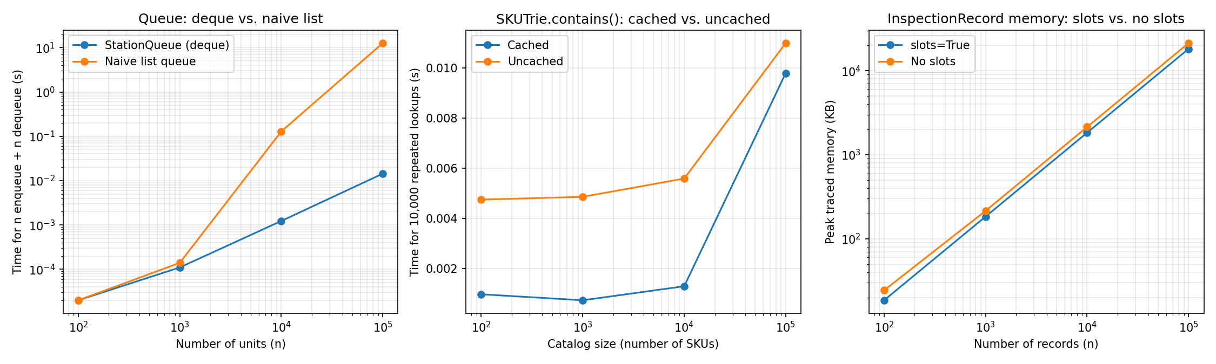
Managing memory at scale came down to two changes covered above, slotted records to cut overhead per unit and a bounded StationQueue to stop unlimited growth, plus one testing habit: the 500,000 unit test closed every record afterward and checked that the registry actually went back to empty, instead of just assuming it would.
Testing and Validation
On top of the self tests from Deliverable 2, a new stress_test.py script covers three areas: a large scale run (the 500,000 units above), unusual inputs, and rapid repeated use.
Thirteen edge cases were checked one by one, and all of them passed. An empty serial number and an empty SKU are both accepted instead of rejected, since nothing in either structure needs to reject them. An empty prefix matches every SKU, as expected. Re registering a serial number that is already active wipes its old stage history clean instead of merging with it. A SKU that is 10,000 characters long still inserts and looks up correctly, so the trie has no real length limit. Serial numbers and SKUs with unicode characters work fine, since Python handles unicode natively. A negative priority correctly sorts below zero and positive priorities. Popping an empty TriageQueue or dequeuing an empty StationQueue just returns None instead of crashing. A StationQueue built with maxlen set to zero never holds anything at all. Calling load_many with an empty list does nothing and does not raise an error. Updating a stage on a unit that was already closed correctly raises a KeyError instead of quietly recreating the record.
A churn test ran 200,000 quick start, update, close cycles, reusing a small pool of 1,000 serial numbers to act like a long shift instead of a single batch. Memory was measured before and after with tracemalloc, and it stayed within about 50 KB of baseline after the full run, with the registry back down to zero records. This suggests close_unit is not leaving anything behind after heavy, repeated use.
Performance Analysis
The table below lines up the four comparisons discussed above, each measured at n equal to 100,000, except the trie cache test, which used a 100,000 SKU catalog with 10,000 repeated lookups.
Comparison Phase 2 or naive Optimized Improvement
StationQueue vs. naive list queue 0.712 s 0.028 s 25.1x faster
TriageQueue push loop vs. load_many 0.056 s 0.049 s 1.1x faster
SKUTrie contains, cached vs. not 0.012 s 0.008 s 1.4x faster
InspectionRecord memory, no slots 22,950.4 KB 19,044.2 KB 17.0% smaller
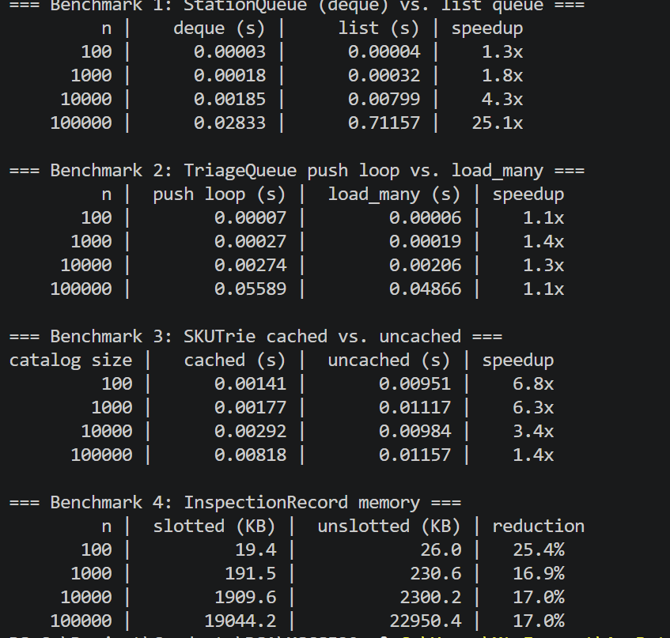
These four results are not all the same kind of claim. The StationQueue row backs up a Phase 1 design choice that was only argued in theory before now, the 25.1x number is proof that already existed on paper, not a brand new optimization. The load_many and caching results are real changes made in this phase, but both gave smaller real world gains than the math would suggest. That is still a useful finding on its own: a better Big O does not always turn into a big speed difference at these sizes, since Python's per operation overhead and, for the trie, memory layout effects can outweigh the theoretical gain. The slots result is the steadiest of the four, since it comes from a fixed saving per object rather than an algorithm change, even though it does not change the worst case complexity.
Final Evaluation
The strongest part of this project is that the time complexity claims from Phase 1, which were only backed by citations before, have now actually been tested. The two clearest results, the deque beating a naive list by about 25 times and slotted records saving about 17 percent of memory, both held up under real measurement. The weakest part is that two of the four changes made in this phase, bulk loading and lookup caching, gave smaller real gains than expected, and the caching test in particular showed a real limit that Phase 1 did not predict: trie lookups are not perfectly independent of catalog size in practice, even though they are in theory.
The limits carried over from Phase 1 and Phase 2 are still unresolved and should not be treated as fixed just because this phase focused elsewhere. None of the four structures are thread safe, the registry still has no real way to save its data permanently, and the trie still cannot handle a misread OCR code on its own. Adding thread safety would be the most natural next step, since every test here ran on a single thread, and a real line with several cameras or scanners updating the registry at the same time would need locks before these numbers could be trusted under real, simultaneous use. Another area worth exploring is whether the trie's slowdown at large catalog sizes could be reduced by storing each node's children in a small array instead of a dictionary, since SKUs in this system only use uppercase letters and digits, a small, fixed set of characters.

References
Ettalibi, A., Elouadi, A., & Mansour, A. (2024). AI and computer vision-based real-time quality control: A review of industrial applications. Procedia Computer Science, 231, 212 to 220. https://doi.org/10.1016/j.procs.2023.12.195
Maślanka, M., Jancarczyk, D., & Rysinski, J. (2025). Integration of machine vision and PLC-based control for scalable quality inspection in Industry 4.0. Sensors, 25(20), 6383. https://doi.org/10.3390/s25206383
Tapia-Fernández, S., García-García, D., & García-Hernandez, P. (2022). Key concepts, weakness and benchmark on hash table data structures. Algorithms, 15(3), 100. https://doi.org/10.3390/a15030100

